[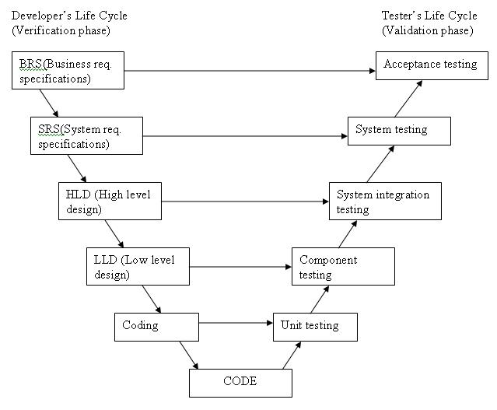](http://istqbexamcertification.com/wp-content/uploads/2012/01/V-model.jpg)

Original Source:

[Kevin Forsberg](http://en.wikipedia.org/wiki/Kevin_Forsberg) and [Harold Mooz](http://en.wikipedia.org/wiki/Harold_Mooz), “The Relationship of System Engineering to the Project Cycle,” in Proceedings of the First Annual Symposium of National Council on System Engineering, October 1991: 57–65.